UNIVERSITY ADMIT ELIGIBILITY PREDICTOR

## TEAM ID: PNT2022TMID04255

**TEAM MEMBERS:** THARUNKUMAR K, NAVIN KISHORE R, THARUN RAJ D, PITCHUMANI S M

# INTRODUCTION:

## 1.1. Project Overview

This project overlooks on the prediction or scope of a student who is aspiring to pursue a master’s degree in the course he / she desires to get into. A Machine Learning model is deployed to predict the chances of eligibility.

## 1.2 Purpose

The simplest way to determine which universities or colleges a person will be admitted to is through university prediction. This method is also completely unbiased and open-book. Individuals would no longer be need to rely on consultancies that may have contracts with a list of schools or universities but may be slightly biassed in that direction. Additionally, limiting applications to only those colleges or universities where a student has a real chance would speed up the application process.

# LITERATURE SURVEY:

## Existing Problem

The main drawback of the previous research done on this is they didn’t consider all the factors which will contribute in the student admission process like TOEFL, SOP, LOR and under graduate score. This in turn creates a sense of fear amongst students who use prediction websites & get falsified results.

## References

* + - *College Admission Predictor:*

[*https://www.jncet.org/Manuscripts/Volume-8/Issue-4/Vol-8-issue-4-M-32.pdf*](https://www.jncet.org/Manuscripts/Volume-8/Issue-4/Vol-8-issue-4-M-32.pdf)

* + - *GRADUATE ADMISSION PREDICTION USING MACHINE LEARNING* [*https://www.researchgate.net/publication/348433004_Graduate_Admission_Prediction_U*](https://www.researchgate.net/publication/348433004_Graduate_Admission_Prediction_Using_Machine_Learning)[*sing_Machine_Learning*](https://www.researchgate.net/publication/348433004_Graduate_Admission_Prediction_Using_Machine_Learning)
    - *GRADUATE ADMISSION CHANCE PREDICTION USING DEEP NEURAL NETWORK:* [*https://ieeexplore.ieee.org/abstract/document/9397988*](https://ieeexplore.ieee.org/abstract/document/9397988)
    - *Graduate University Admission Predictor using Machine Learning:* [*https://www.ijmtst.com/volume6/issue12/92.IJMTST0612246.pdf*](https://www.ijmtst.com/volume6/issue12/92.IJMTST0612246.pdf)
    - *A Statistical Approach to Graduate Admissions’ Chance Prediction:* [*https://www.researchgate.net/publication/339653123_A_Statistical_Approach_to_Gradua*](https://www.researchgate.net/publication/339653123_A_Statistical_Approach_to_Graduate_Admissions%27_Chance_Prediction)[*te_Admissions'_Chance_Prediction*](https://www.researchgate.net/publication/339653123_A_Statistical_Approach_to_Graduate_Admissions%27_Chance_Prediction)

## Problem Statement Definition

Concerns about getting into college are common among students. This project's goal is to assist students in narrowing down institutions based on their profiles. The anticipated results offer students a good indication of their prospects of admission to a certain university. This study ought to provide greater insight for students who are or will be preparing for exams.

# IDEATION & PROPOSED SOLUTION:

## Empathy map canvas

An empathy map is a straightforward, simple-to-understand picture that summarises information about a user's actions and views.

It is a helpful tool that enables teams to comprehend their users more fully.

It's important to comprehend both the actual issue and the individual who is experiencing it in order to develop a workable solution. Participants learn to think about issues from the user's perspective, as well as his or her objectives and obstacles, via the process of constructing the map.

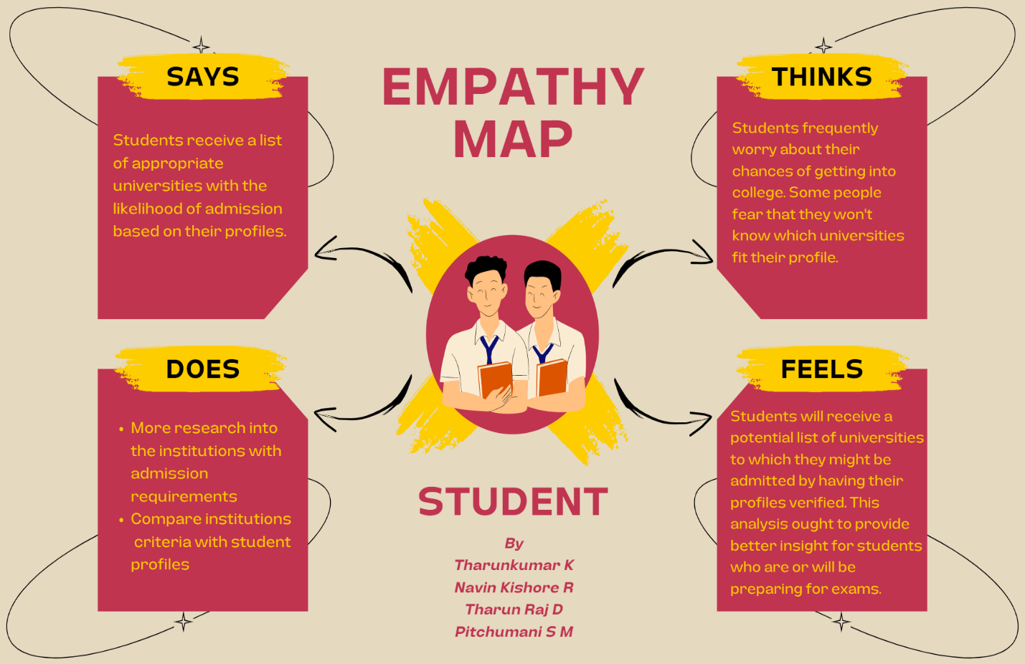

## Ideation & Brainstorming

uring a brainstorming session, everyone in a team is encouraged to engage in the process of original thought that results in issue solutions. Volume over quality is prioritised, unconventional ideas are welcomed and developed upon, and everyone is urged to participate in order to produce a wealth of original solutions.

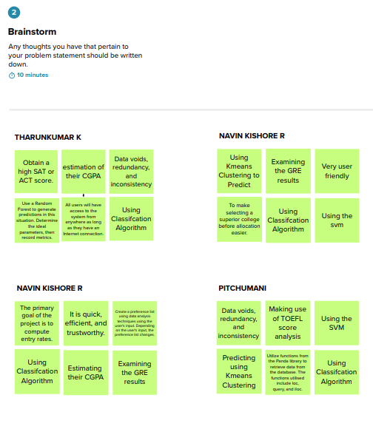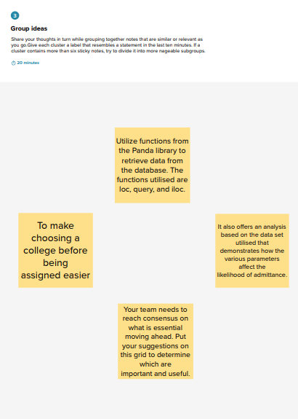

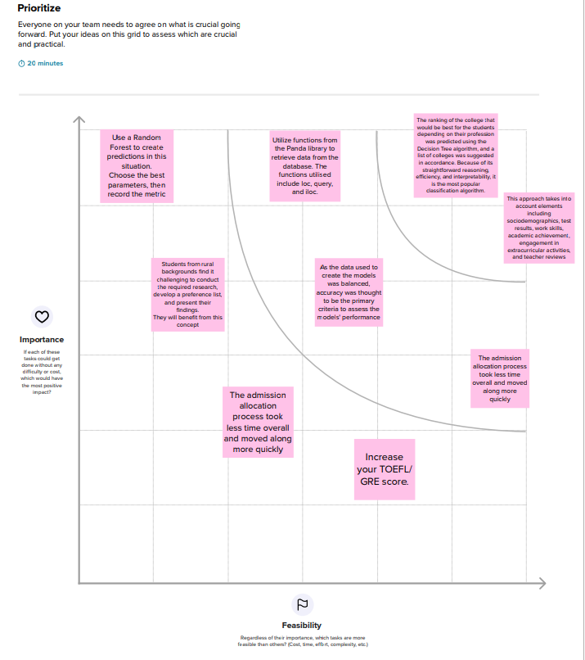

## Proposed Solution

|  |  |  |
| --- | --- | --- |
| **S.No.** | **Parameter** | **Description** |
| 1. | Problem Statement (Problem to be solved) | Education institutions use online applications for admissions and eligibility criteria based on marks, but there are no set procedures followed for predicting a student's admission to the university. Instead, they investigate and take measures to predict their eligibility for enrolling  in the course. |

|  |  |  |
| --- | --- | --- |
| 2. | Idea / Solution description | We intend to put into practise an effective system for assessing a candidate's suitability for admission to a university. |
| 3. | Novelty / Uniqueness | We look forward to mentioning a wide range of information about the university that the student is qualified to attend, including geographic data, cultural information, details about alumni, information about the university's top courses, admit percentage, job prospects after  graduation, and peer reviews, which are additional features. |
| 4. | Social Impact / Customer Satisfaction | By offering information directly from students who recently graduated from the university and guiding us toward courses that are relevant to  our profiles, it makes it easier to use the website to enrol in the university. |
| 5. | Business Model (Revenue Model) | It is offered for free. |
| 6. | Scalability of the Solution | The more users there are, the easier it will be to collect input and work on system improvements. In turn, the model may be trained to make predictions more accurately  based on the feedback. |

* 1. **Problem Solution Fit**

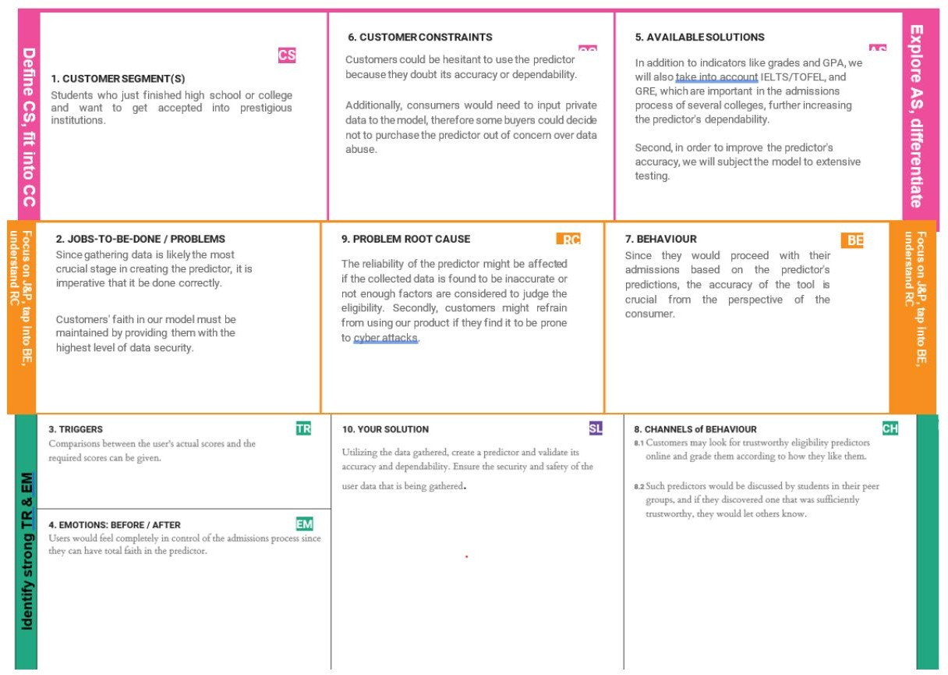

# REQUIREMENT ANALYSIS:

## Functional Requirements

Following are the functional requirements of the proposed solution**.**

|  |  |  |
| --- | --- | --- |
| **FR**  **No.** | **Functional Requirement (Epic)** | **Sub Requirement (Story / Sub-Task)** |
| FR-1 | User Registration | Registration through Form Registration through Gmail |
| FR-2 | User Confirmation | Confirmation via Email Confirmation via OTP |
| FR-3 | User Details | Submit the paperwork   * Score report for the GRE or TOEFL * Curriculum Vitae (CV) * Recommendation letter * Statement of Purpose (SoP) |
| FR-4 | User Requirements | * Upload all necessary files to the proper area of the website. * Based on the uploads, the system would extract the necessary data. * A list of every probable university for the   candidate would be shown based on the information that was scraped. |

## Non- Functional Requirements

Following are the non-functional requirements of the proposed solution.

|  |  |  |
| --- | --- | --- |
| **FR No.** | **Non-Functional Requirement** | **Description** |
| NFR-1 | **Usability** | * Even a beginner user can access the system because it doesn't require any prior technological expertise from them. * The user interface would give recognition more weight than recall. * Friendly to users * Be aware of internal sources of control * The loading and display of the content wouldn't take too long (30 seconds). * The site's fields would be self-explanatory. |
| NFR-2 | **Security** | * The site's services may only be accessed by authorised users. * Every hour, the database has to be backed up. * The system should be able to resume normal operation in less than an hour in the case of any errors. |
| NFR-3 | **Reliability** | * Given the importance of the data and the potential damage * The damage that erroneous or inadequate data * System will constantly aim for the highest level of dependability. * The system will function every day of the week. |

|  |  |  |
| --- | --- | --- |
| NFR-4 | **Performance** | * The website may effectively manage traffic by quickly responding to queries. * This webpage may be seen in less than 30 seconds using a 64 kbps modem connection (quantitatively, the mean time) |
| NFR-5 | **Availability** | Low data redundancy, lower danger of mistake, and quick and efficient |
| NFR-6 | **Scalability** | * An academic portal is required for the courses that use it, therefore a large number of users must be able to use the system at once. * The system must be able to accommodate several users at once because the admissions season is   likely to be its busiest time. |

# PROJECT DESIGN:

## Data Flow Diagrams

The classic visual depiction of how information moves through a system is a Data Flow Diagram (DFD). A tidy and understandable DFD may visually represent the appropriate quantity of the system demand. It demonstrates how information enters and exits the system, what modifies the data, and where information is kept.

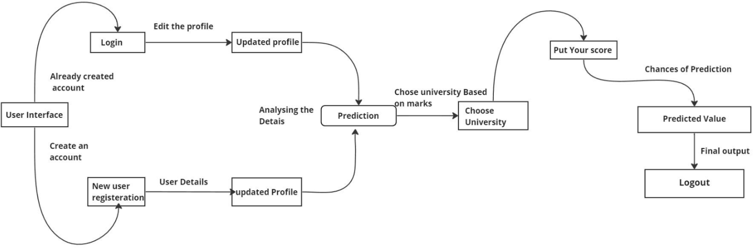

## Solution & Technical Architecture

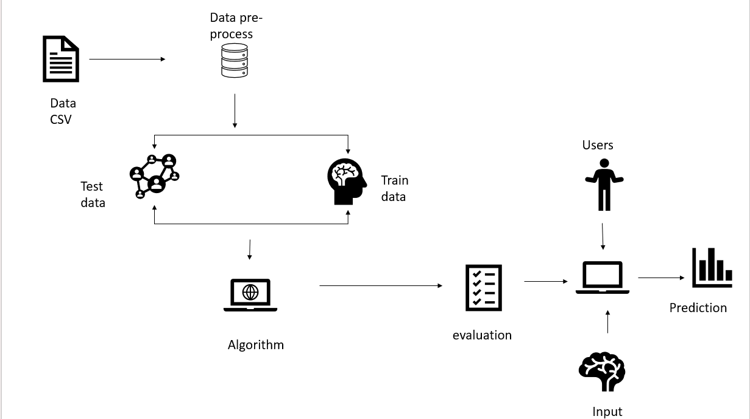

* 1. 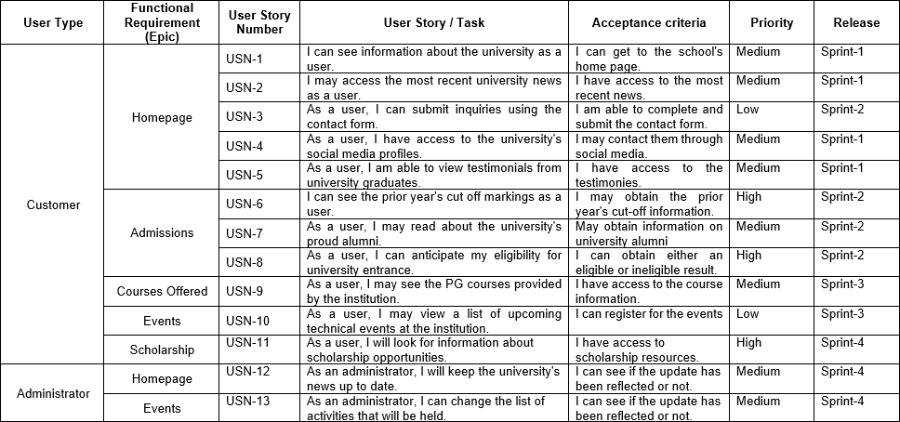**User Stories**

# PROJECT PLANNING & SCHEDULING:

## Sprint Planning & Estimation

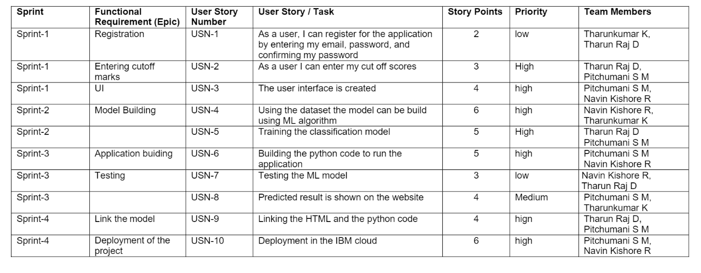

* 1. 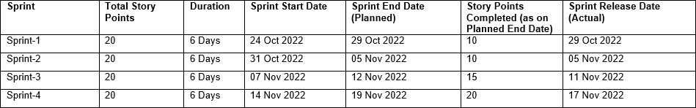**Sprint Delivery Schedule**
  2. **Reports from JIRA**

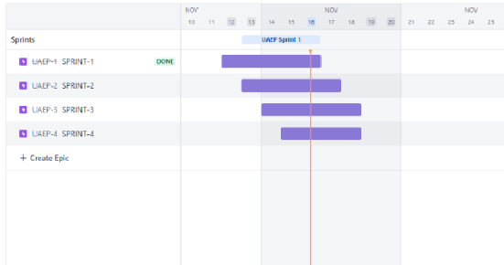

# CODING & SOLUTIONING:

## Feature 1

**INDEX.HTML**

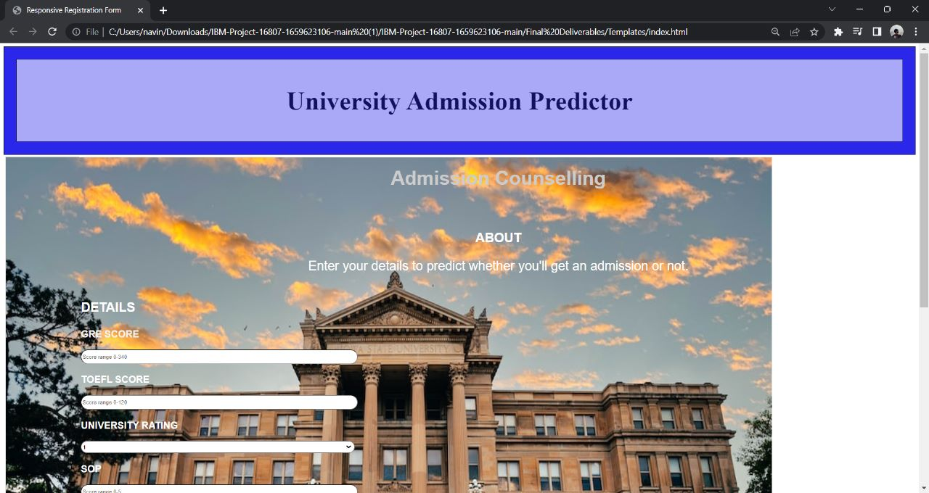

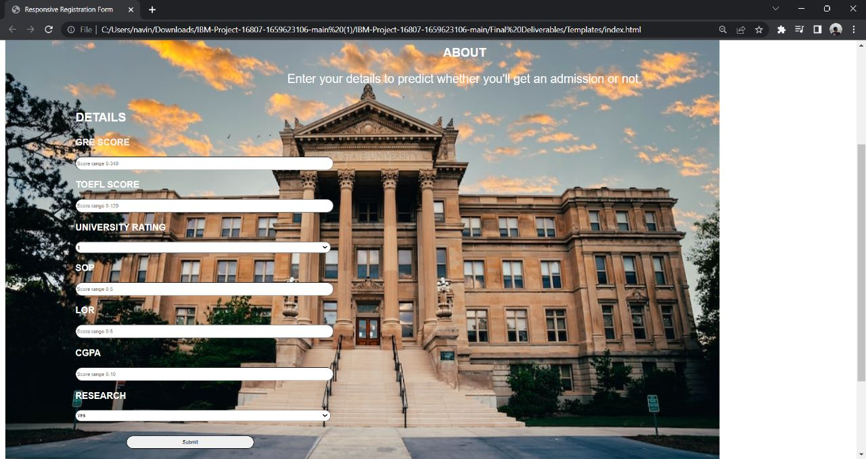

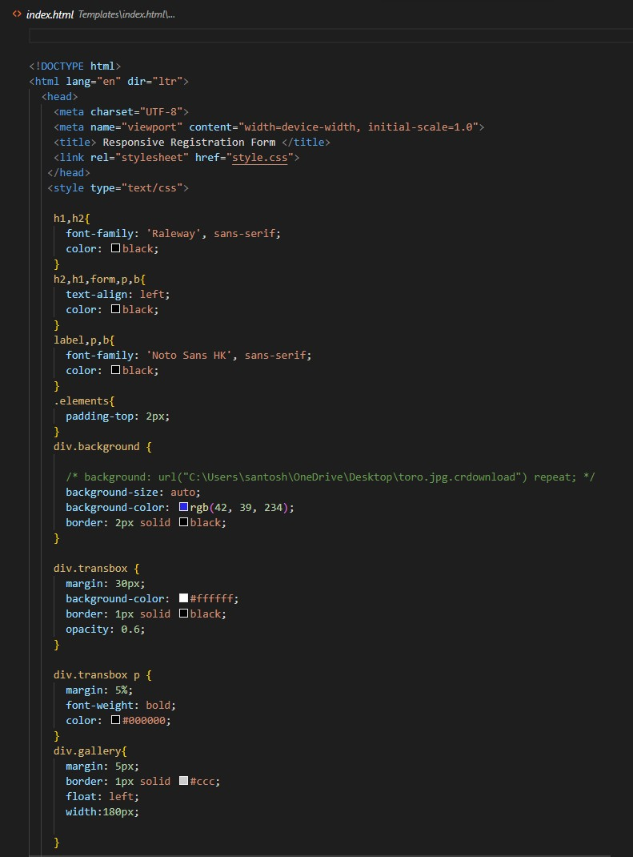

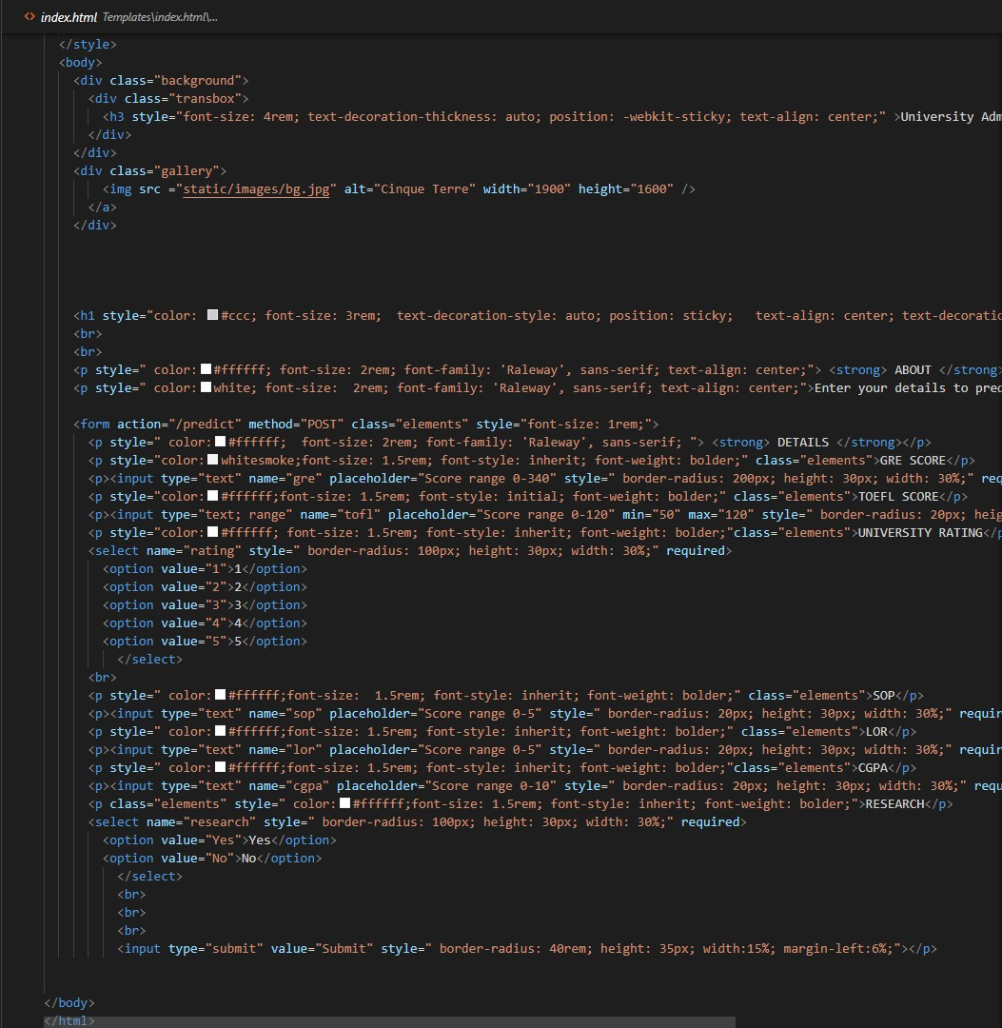

## Feature 2

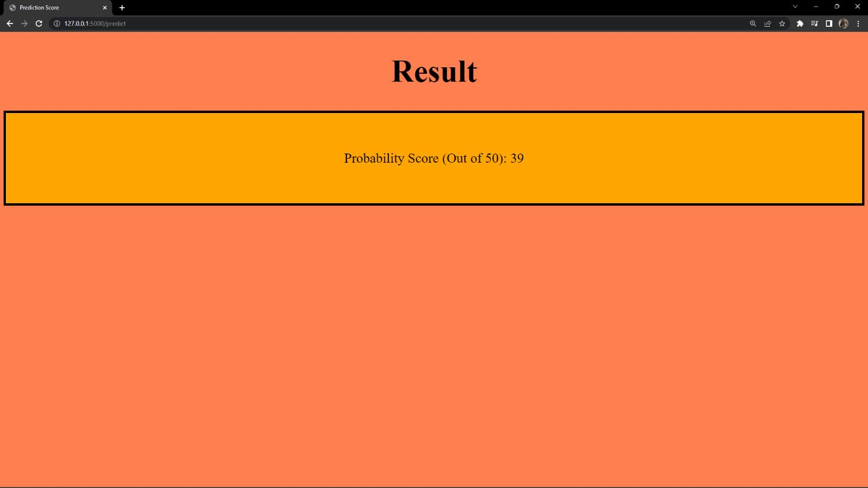**RESULT.HTML**

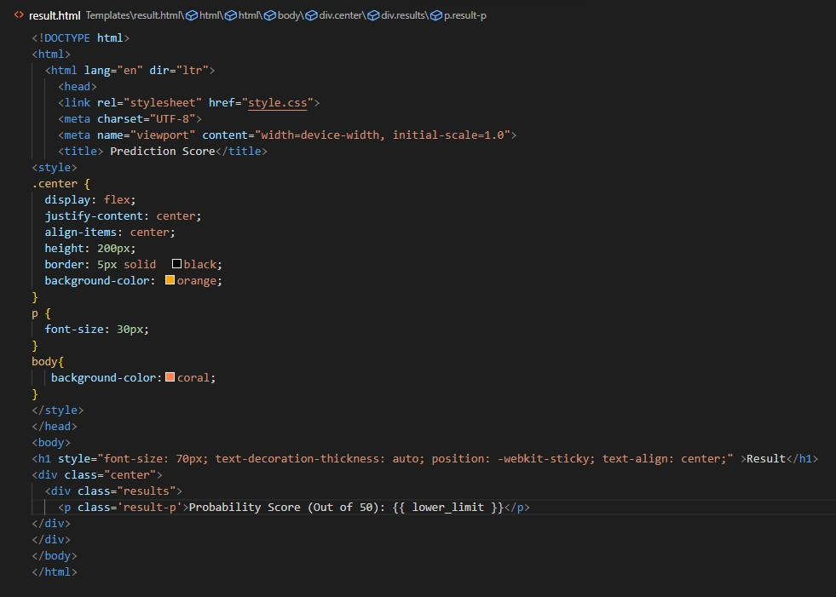

## FLASK FILE TO INTEGRATE WEBSITE (app.py):

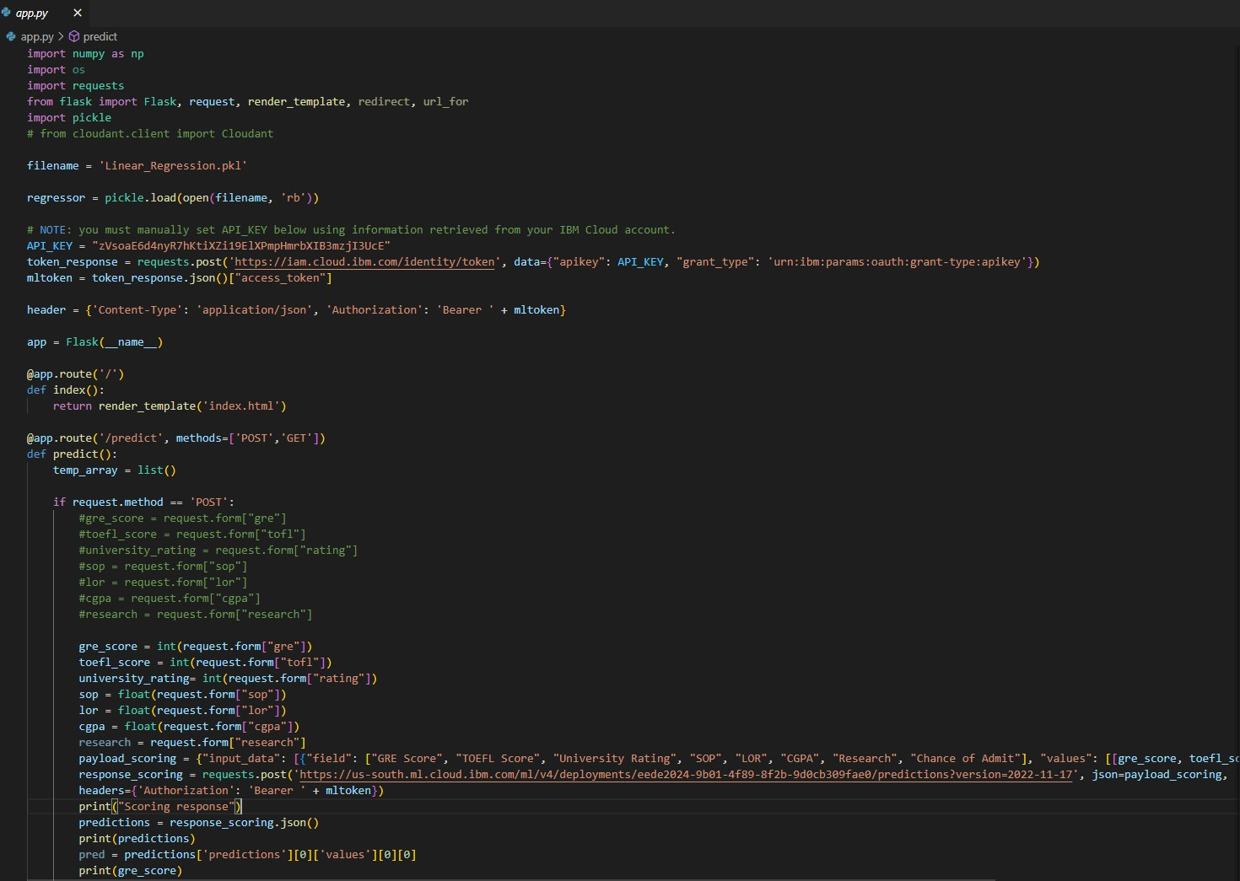

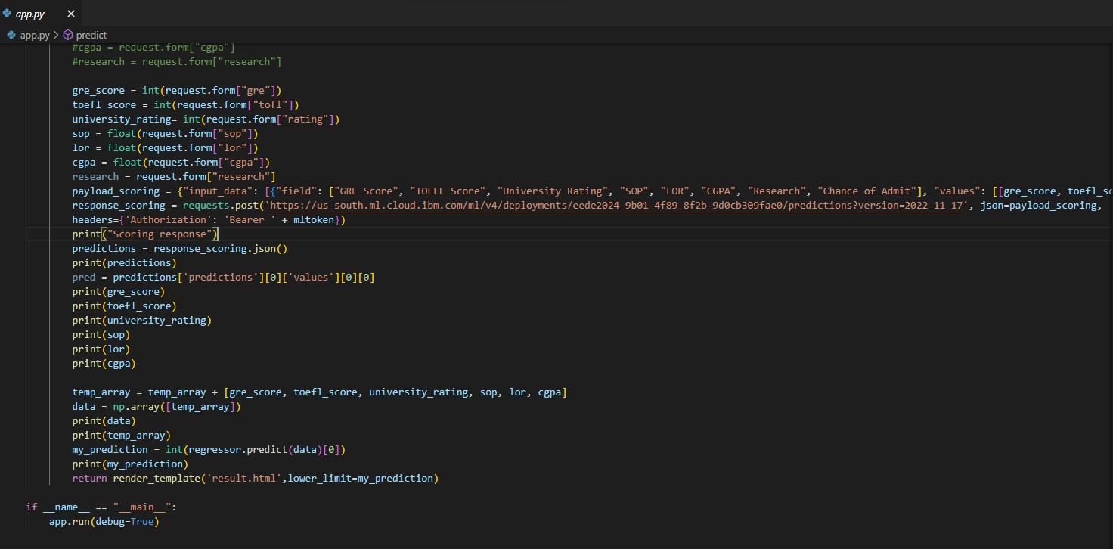

* 1. **Database Schema**

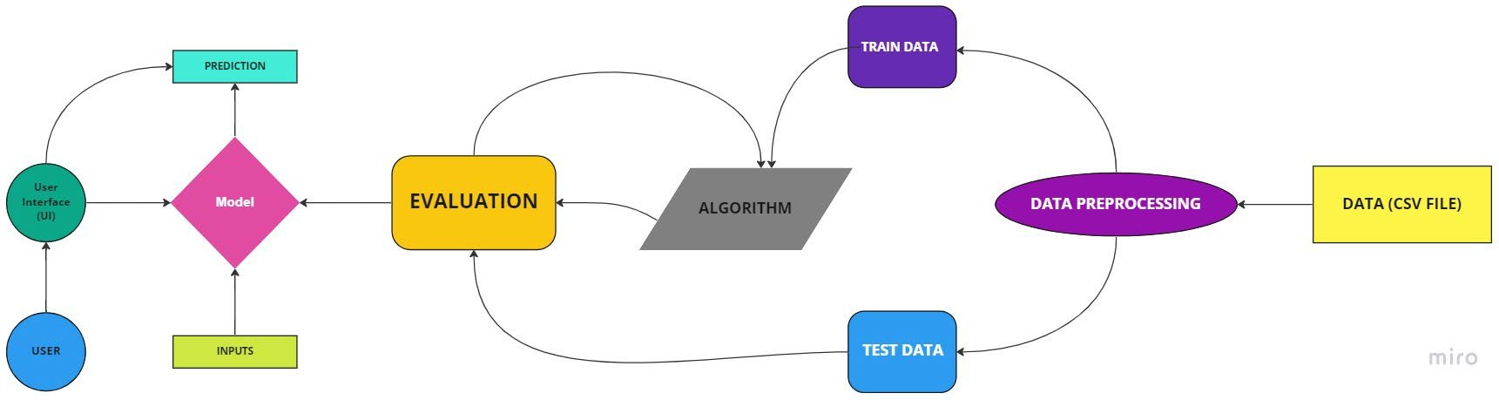

# TESTING:

## Test Cases

|  |  |  |  |  |  |  |  |  |  |  |
| --- | --- | --- | --- | --- | --- | --- | --- | --- | --- | --- |
| **Test case ID** | **Feature Type** | **Componen**  **t** | **Test Scenario** | **Pre-Requisite** | **Steps To Execute** | **Test Data** | | **Expected Result** | **Actual**  **Result** | **Status** |
| LoginPage_TC_OO 2 | UI | Index | Verify the UI elements in home page |  | 1.Enter URL and click go 2.Enter the Scores  3.Click the Submit button | http://127.0.0.1:5000/home | | Working as expected | Working as expected | Pass |
| LoginPage_TC_OO 3 | Functional | Chance | Verifying whether the student is eligible for admission |  | 1.As per the Entered Model Value. 2.Getting above 50%.  3.You have a Chance will get displayed | http://127.0.0.1:5000/chanc e/90.1742255758468 | | Working as expected | Working as expected | Pass |
|  |  |
| LoginPage_TC_OO 4 | Functional | NoChance | Verifying whether the student does not have a chance of admission |  | 1. As per the Entered Model Value. 2. Getting below 50% 3. You have a Low/Nochance will get displayed | http://127.0.0.1:5000/nocha nce/41.52682121752442 | | Working as expected | Working as expected | Pass |

* 1. **User Acceptance Testing**

The purpose of User Acceptance Testing is to briefly explain the test coverage and open issues of the University Admit Eligibility Predictor project at the time of the release to User Acceptance Testing (UAT).

## Defect Analysis

This report shows the number of resolved or closed bugs at each severity level, and how they were resolved

|  |  |  |  |  |  |
| --- | --- | --- | --- | --- | --- |
| **Resolution** | **Severity 1** | **Severity 2** | **Severity 3** | **Severity 4** | **Subtotal** |
| By Design | 10 | 4 | 2 | 3 | 20 |
| Duplicate | 1 | 0 | 3 | 0 | 4 |
| External | 2 | 3 | 0 | 1 | 6 |
| Fixed | 11 | 2 | 4 | 20 | 37 |
| Not Reproduced | 0 | 0 | 1 | 0 | 1 |
| Skipped | 0 | 0 | 1 | 1 | 2 |
| Won't Fix | 0 | 5 | 2 | 1 | 8 |
| Totals | 24 | 14 | 13 | 26 | 77 |

## Test Case Analysis

This report shows the number of test cases that have passed, failed, and untested

|  |  |  |  |  |
| --- | --- | --- | --- | --- |
| **Section** | **Total Cases** | **Not Tested** | **Fail** | **Pass** |
| Print Engine | 7 | 0 | 0 | 7 |
| Client Application | 45 | 0 | 0 | 45 |
| Security | 2 | 0 | 0 | 2 |
| Outsource Shipping | 3 | 0 | 0 | 3 |
| Exception Reporting | 9 | 0 | 0 | 9 |
| Final Report Output | 4 | 0 | 0 | 4 |
| Version Control | 2 | 0 | 0 | 2 |

# RESULTS:

## 9.1 Performance Metrics

|  |  |  |  |
| --- | --- | --- | --- |
| **S.No.** | **Parameter** | **Values** | **Screenshot** |
| 1. | Metrics | **Regression Model:**  MAE - , 0.04555 MSE - , 0.00426 RMSE – 0.06527 ,  R2 score – 0.71683  **Classification Model:**  Confusion Matrix - Accuracy Score- Classification Report - | C:\Users\sasha\AppData\Local\Microsoft\Windows\INetCache\Content.MSO\CA6AE880.tmp |

|  |  |  |  |
| --- | --- | --- | --- |
| 2. | Tune the Model | Hyperparameter Tuning- Validation Method – Stratified K-Fold |  |

1. **ADVANTAGES & DISADVANTAGES**

**Advantages**

* + It helps student for making decision for choosing a right college.
  + Here the chance of occurrence of error is less when compared with the existing system.
  + It is fast, efficient and reliable.
  + Avoids data redundancy and inconsistency.
  + Very user-friendly.
  + Easy accessibility of data.

**Disavantages:**

* + Required active internet connection.
  + System will provide inaccurate results if data entered incorrectly.

## CONCLUSION

Thus it is concluded that our model provides a robust prediction score with Multiple Linear Regression Algorithm & users are able to predict the scores what they expected. User experience of the website is a simple one to use & puts the user at ease to utilize the feature.

## FUTURE SCOPE

We intend to enhance the user experience by adding the details of every universities so that the user can get to know the culture of the place, alumni reviews, rating of the universities etc.

## APPENDIX

Github : <https://github.com/IBM-EPBL/IBM-Project-25823-1659974175>

Project Demo: <https://www.youtube.com/watch?v=li78Ih3Pmu4>